The highest determinants of price of a used BMW are Engine Size, Mileage, Year, and Transmission. Larger engines and newer years increase the price, while higher mileage and manual transmissions decrease it.
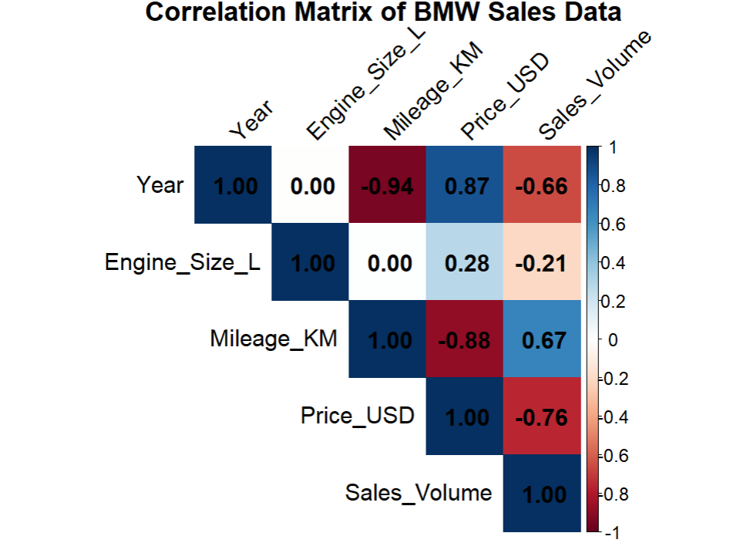
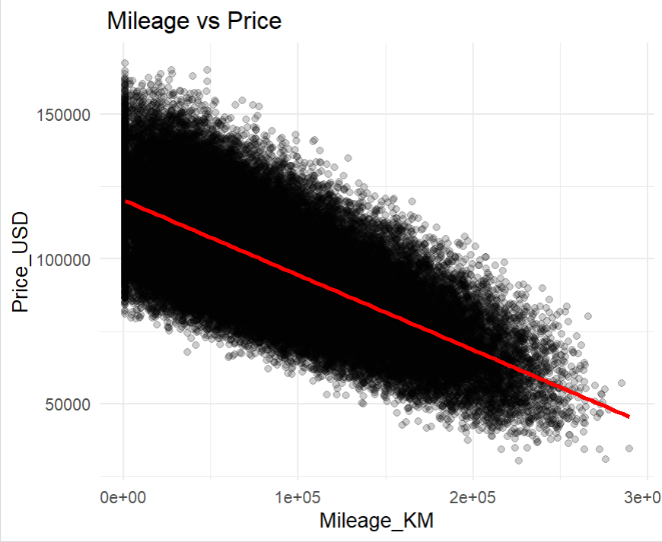

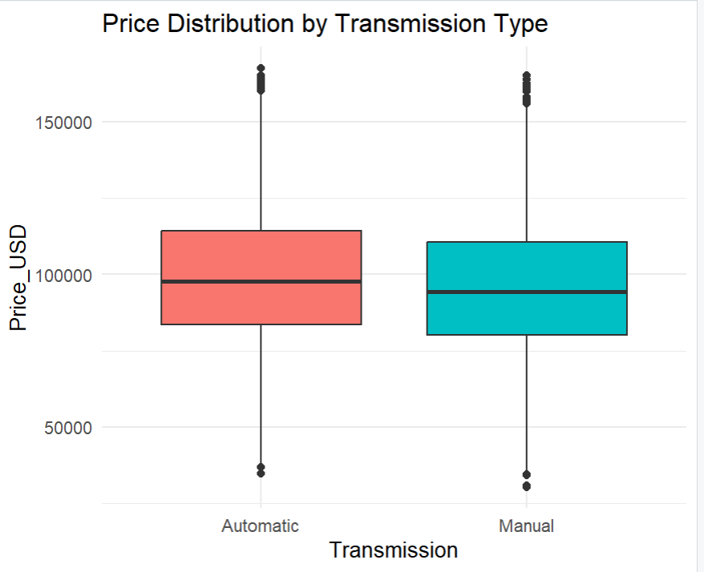
How features of a vehicle like Engine Size, Mileage, Fuel Type and Transmission affect the final sale price and volume of sales.
Effect on Sale Price: Engine Size and Year have a strong positive effect on price. Mileage and a Manual Transmission have a strong negative effect. Fuel Type has a minimal impact.
Effect on Sales Volume: Price has the most direct impact: as price increases, sales volume decreases. Other features like Engine Size and Mileage affect sales indirectly by first changing the car's price.

